SIMATS ENGINEERING
ASSESSMENT TOOL 2: Industry Problem Solving Task
COURSE NAME: Cloud Computing and Big Data Analytics
COURSE OUTCOME COVERED
COURSE CODE: CSA15
CO4: Analyze big data characteristics and challenges across domains including security and application aspects. (BL4)
Dave's Taxonomy: Articulation (Level 4) Question Count: 5
Code of Conduct
Total Marks: 40
I S.PRATEEKSHA-192572137 (Name / Reg. No.) certify that this submission is my original work and that I have adhered to the guidelines specified for this assessment. I understand that any violation of academic integrity rules will result in disciplinary action. Signature of the student:S.PRATEEKSHA
Assessment Tasks
Industry Problem Solving Task
1. Retail Data Optimization Problem - A retail chain operates both physical stores and an online platform. It generates large volumes of sales, inventory, and customer behavior data. The company wants real-time inventory tracking and demand forecasting. It also aims to deliver personalized marketing recommendations to customers. Design a big data architecture to support these requirements. Explain the tools, technologies, and analytics models you would use.
2. Social Media Fraud Detection Problem - A social media platform processes billions of user interactions daily. These include posts, comments, likes, and shares. The platform wants to detect fake accounts and misinformation quickly. Real-time or near real-time processing is required. Design a scalable big data solution for this use case. Explain the role of machine learning and stream processing frameworks.
3. Government Data Platform Problem A government agency is building a national data platform. It combines census, economic, and geospatial datasets. Different departments need access to shared and integrated data. The system must ensure interoperability across multiple agencies. Strict privacy and security requirements must be followed. Propose a governance and data management strategy.
4. Banking Fraud Detection Problem
A bank processes millions of financial transactions every minute. It needs to detect fraudulent activities in real time. The system must analyze historical and streaming transaction data.
Low latency and high accuracy are critical requirements. Design a big data pipeline for fraud detection. Explain the technologies and algorithms you would implement.
5. Agriculture Smart Farming Problem
A smart farming system collects soil, weather, and crop data. Sensors and drones provide real-time field information. Farmers want insights to improve yield and resource usage. Data is generated from multiple distributed sources. Design a big data solution for precision agriculture. Explain how analytics can support decision-making.
Industry Problem Solving Rubric
Criteria | Weightage | Level 4 - Exemplary | Level 3 -  Proficient | Level 2 -  Developing | Level 1 -  Beginning | Total  Marks
Understanding of Industry Context | 20% | Demonstrates strong understanding of real world problem  context | Good  understanding | Basic  understanding | Weak  understanding
Application of  Big Data  Concepts | 25% | Applies highly  relevant big data  ideas and tools | Mostly  appropriate  application | Partial  application | Weak  application
Solution Design | 25% | Solution is practical, scalable, and well  reasoned | Reasonable  solution | Basic solution with gaps | Unclear  solution
Security / Risk  Awareness | 15% | Strong awareness of security and  operational risks | Reasonable  awareness | Limited  awareness | Poor  awareness
Clarity and  Professionalism | 15% | Well-structured and professional response | Generally clear | Moderately  clear | Poorly  presented

Total Marks Awarded:

Assessment Tasks – Industry Problem Solving Task
1. Retail Data Optimization Problem
Proposed Big Data Architecture
A retail chain can use a Lambda/Kappa-style big data architecture to process both real-time and historical data.
Data Sources:
- Point-of-Sale (POS) systems from physical stores
- E-commerce transactions
- Inventory management systems
- Customer browsing and purchase history
- Mobile applications and loyalty programs
Data Ingestion:
- Apache Kafka collects real-time sales, inventory, and customer events.
- Apache NiFi can be used for data integration from different sources.
Data Storage:
- Hadoop HDFS or a cloud-based data lake stores large volumes of raw and processed data.
- Hive provides SQL-based analysis of large datasets.
- A NoSQL database such as MongoDB/Cassandra can store rapidly changing operational data.
Data Processing:
- Apache Spark performs large-scale batch processing and real-time analytics.
- Spark Streaming processes live sales and inventory events.
Analytics Models:
- Demand Forecasting: Time-series models such as ARIMA, Prophet, or LSTM predict future product demand.
- Customer Segmentation: K-Means clustering groups customers based on purchasing behavior.
- Recommendation System: Collaborative filtering and content-based recommendation models provide personalized products.
- Inventory Optimization: Predictive analytics identifies products that need replenishment.
Architecture Flow
POS / E-commerce / Mobile / Inventory → Kafka → Data Lake → Spark → Analytics & ML → Dashboards / Recommendations / Inventory Alerts
Benefits
- Real-time inventory visibility
- Improved demand forecasting
- Reduced overstock and stockouts
- Personalized customer recommendations
- Faster business decision-making

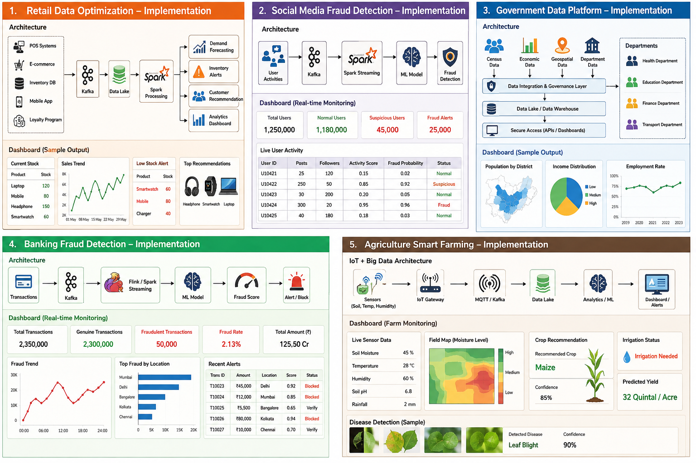

2. Social Media Fraud Detection Problem
Proposed Big Data Solution
A social media platform requires a highly scalable real-time streaming architecture because billions of interactions are generated every day.
Data Sources:
- Posts
- Comments
- Likes
- Shares
- Login activity
- Friend/follower relationships
- User profiles
- IP and device information
Data Ingestion
Apache Kafka acts as the central event-streaming platform. Every user activity is converted into an event and sent to Kafka topics.
For example:
User Activity → Kafka → Stream Processing → ML Models → Fraud/Misinformation Detection
Stream Processing
Apache Spark Structured Streaming or Apache Flink processes events continuously.
The system can calculate features such as:
- Unusual posting frequency
- Sudden increase in followers
- Repeated content
- Abnormal sharing patterns
- Multiple accounts using similar behavior
- Suspicious login locations or devices
Machine Learning
Machine learning can classify accounts and content.
Fake Account Detection:
- Random Forest
- Gradient Boosting
- Neural Networks
- Graph-based machine learning
Misinformation Detection:
- Natural Language Processing (NLP)
- Text classification
- Transformer-based models
- Sentiment and semantic analysis
A graph database/graph analytics system can analyze relationships among users, posts, and accounts to identify coordinated fraudulent networks.
Storage
- HDFS/Data Lake: Historical data
- NoSQL: User and activity data requiring fast access
- Data Warehouse: Reporting and long-term analytics
Benefits
- Near real-time fraud detection
- Scalable processing of billions of events
- Automatic identification of suspicious accounts
- Faster detection of misleading content
- Continuous improvement through machine learning



3. Government Data Platform Problem
Proposed Governance and Data Management Strategy
The government should establish a centralized data platform/data lakehouse that integrates census, economic, geospatial, and departmental datasets while maintaining strict security and privacy.
Data Sources
- Census databases
- Economic and financial datasets
- Tax and administrative datasets
- Geographic Information System (GIS) data
- Department-specific databases
Data Integration
ETL/ELT tools can extract, transform, and load data from different departments.
A common data model and standardized formats such as JSON, XML, CSV, and standardized geospatial formats should be used to ensure interoperability.
Data Storage
A government data lake can store raw data, while a data warehouse/lakehouse stores cleaned and integrated datasets for analysis.
Data Governance
A strong governance framework should include:
- Data Ownership – Every dataset must have a responsible department or data owner.
- Data Quality – Data should be checked for accuracy, completeness, consistency, and duplication.
- Metadata Management – Metadata should describe the source, format, meaning, and usage of each dataset.
- Data Standards – Common schemas and APIs should be adopted across departments.
- Data Lifecycle Management – Data should be retained, archived, or deleted according to defined policies.
Security and Privacy
- Role-Based Access Control (RBAC)
- Multi-factor authentication
- Data encryption during storage and transmission
- API gateways and firewalls
- Audit logs
- Data masking and anonymization
- Privacy-preserving analytics
Interoperability
Departments can communicate through secure APIs and standardized data exchange formats. A central data catalog allows authorized departments to discover available datasets.
Architecture Flow
Government Departments → Secure APIs/ETL → Data Lake/Lakehouse → Data Governance & Security → Analytics → Authorized Departments
Benefits
- Unified national data platform
- Better data sharing between departments
- Improved policy decisions
- Reduced duplicate data collection
- Strong privacy and security
- Standardized interoperability



4. Banking Fraud Detection Problem
Proposed Big Data Pipeline
A bank needs a real-time streaming fraud detection system capable of processing millions of transactions with very low latency.
Data Sources
- ATM transactions
- Credit/debit card transactions
- Online banking
- Mobile banking
- Fund transfers
- Customer profiles
- Historical transaction records
Data Ingestion
Apache Kafka receives transactions in real time.
Example:
Transaction → Kafka → Stream Processing → Feature Engineering → Fraud Model → Decision Engine
Stream Processing
Apache Flink or Spark Structured Streaming can analyze transactions immediately.
The system checks:
- Transaction amount
- Transaction location
- Transaction frequency
- Customer spending pattern
- Device information
- Merchant information
- Time between transactions
- Previous fraud history
Machine Learning Algorithms
Supervised Learning:
- Logistic Regression
- Random Forest
- XGBoost
These models can classify transactions as legitimate or suspicious.
Unsupervised Learning:
- Isolation Forest
- K-Means
- Autoencoders
These methods can identify unusual transaction patterns even when labeled fraud data is limited.
Rule-Based Detection
Machine learning can be combined with predefined rules.
For example:
- Unusual transaction amount
- Multiple transactions within a very short period
- Suspicious geographic movement
- Repeated failed authentication attempts
Storage
- Data Lake/HDFS: Historical transactions
- NoSQL Database: Fast access to customer and transaction information
- Data Warehouse: Fraud reports and historical analysis
Decision System
The system can assign a fraud probability score.
- Low score → Approve transaction
- Medium score → Additional verification
- High score → Block/hold transaction and generate alert
Benefits
- Real-time fraud detection
- Low transaction-processing latency
- Improved fraud detection accuracy
- Reduced financial losses
- Continuous learning from historical fraud patterns

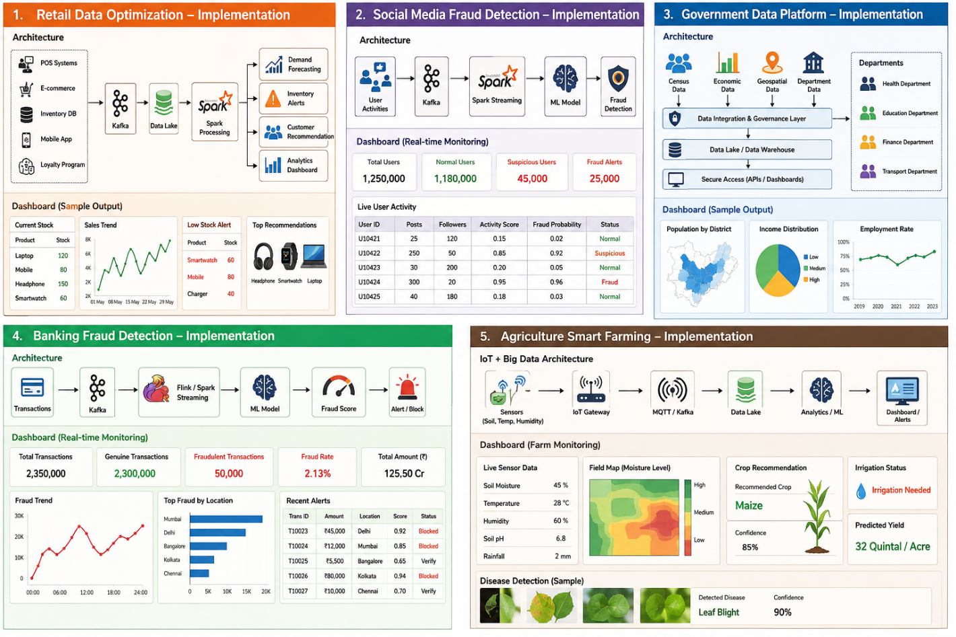
5. Agriculture Smart Farming Problem
Proposed Big Data Solution
Precision agriculture can use IoT sensors, drones, weather systems, satellite data, and machine learning to continuously monitor agricultural fields.
Data Sources
- Soil moisture sensors
- Soil temperature sensors
- pH sensors
- Weather stations
- Drones
- Satellite images
- Crop growth information
- Irrigation systems
- Historical yield data
Data Collection and Ingestion
IoT sensors continuously generate field data. MQTT, IoT gateways, and Apache Kafka can collect and transmit sensor data.
Sensors/Drones → IoT Gateway → Kafka → Data Lake → Analytics/ML → Farmer Dashboard
Data Storage
- Cloud Data Lake: Stores large volumes of sensor, drone, satellite, and historical data.
- NoSQL Database: Stores real-time sensor readings.
- Data Warehouse: Stores summarized agricultural information.
Data Processing
Apache Spark can process large datasets from different farms and identify patterns.
Analytics and Machine Learning
1. Crop Yield Prediction
- Linear Regression
- Random Forest
- XGBoost
- Neural Networks
These models estimate expected crop yield using soil, weather, and historical data.
2. Irrigation Optimization
Sensor data can determine when crops require water and help avoid unnecessary irrigation.
3. Disease Detection
Drone or satellite images can be analyzed using CNN/deep learning models to identify possible crop diseases.
4. Fertilizer Recommendation
Soil nutrients, crop type, and historical yield data can be analyzed to recommend suitable fertilizer application.
5. Weather-Based Decision Making
Weather forecasts can help farmers determine suitable times for irrigation, spraying, and harvesting.
Decision Support
A farmer dashboard can provide:
- Soil moisture alerts
- Irrigation recommendations
- Crop health reports
- Disease alerts
- Yield predictions
- Weather notifications
- Resource usage analysis
Benefits
- Increased crop yield
- Reduced water consumption
- Optimized fertilizer usage
- Early disease detection
- Reduced farming costs
- Better resource management
- Data-driven agricultural decisions


Overall Conclusion
Big data architectures allow organizations to collect, store, process, and analyze massive amounts of structured and unstructured data. Kafka, Hadoop, Spark, Flink, NoSQL databases, cloud data lakes, and machine learning can be combined according to the requirements of each industry. Real-time streaming supports applications such as banking and social media fraud detection, while batch and predictive analytics support retail forecasting, government planning, and precision agriculture.

